有下面的C函数，用基本路径测试法进行测试

void Sort(int iRecordNum,int iType)

1. {
2. int x=0;
3. int y=0;
4. if (iRecordNum-- > 0)
5. {
6. if(0= =iType)
7. { x=y+2; break;}
8. else
9. if (1= =iType)
10. x=y+10;
11. else
12. x=y+20;
13. }
14. }
15. 画出结构流程图

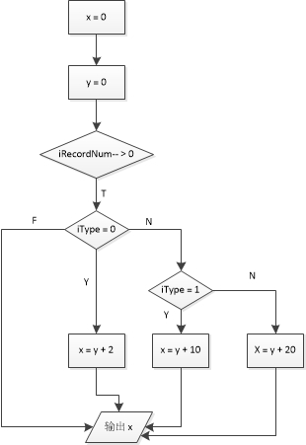

1. 路径和条件组合表

|  |  |  |
| --- | --- | --- |
| 测试用例 | 通过路径 | 覆盖条件 |
| iRecordNum = 2  iType = 0 | a b c | T1 T2 |
| iRecordNum = 2  iType = 1 | a b d e | T1 -T2 T3 |
| iRecordNum = 2  iType = 2 | a b d f | T1 -T2 -T3 |
| iRecordNum = 1  iType = 0 | a | -T1 |